OPEN HOUSE

REDEEMER LUTHERAN PRESCHOOL
March 1st 6:00PM – 7:30PM
What Makes Us Special?
* We are an Accredited School. * All teachers have an AA or BA
which exceeds state standards.
* Chapel services are held twice a week.
* Potty training for 2 year olds.
* Key card access for added security. * Student to teacher ratios are lower than.
state requirements for more individual
attention.
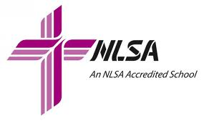
* Our curriculum enriches age-appropriate
development and instills a love for Christ
and learning.

* A weekly comprehensive music program.

16351 Springdale St. Huntington Beach, CA Phone: 714-840-7117

